 **---------------------------------------------------------------------**

**Learn JIRA by Vaibhav**

**---------------------------------------------------------------------**

**JIRA Installation:**

1. <https://www.atlassian.com/> 🡪 https://www.atlassian.com/
2. 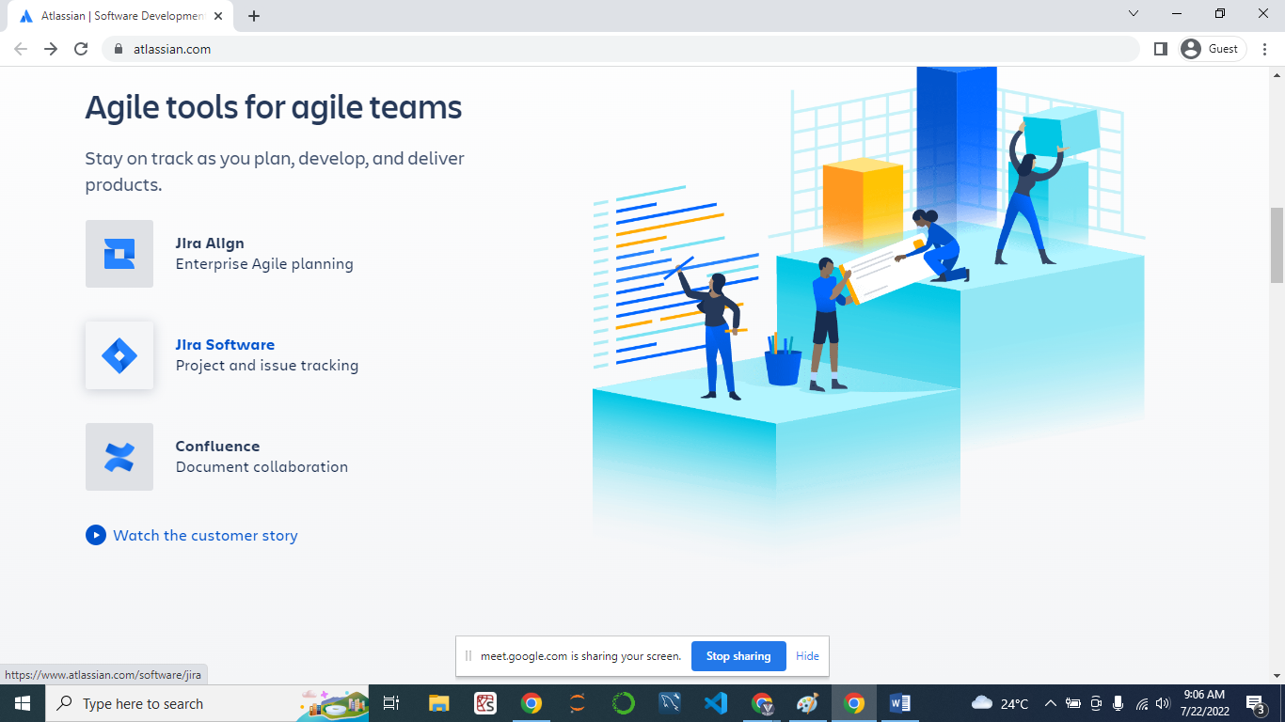
3. Click on Jira Software.
4. Scoll Down
5. 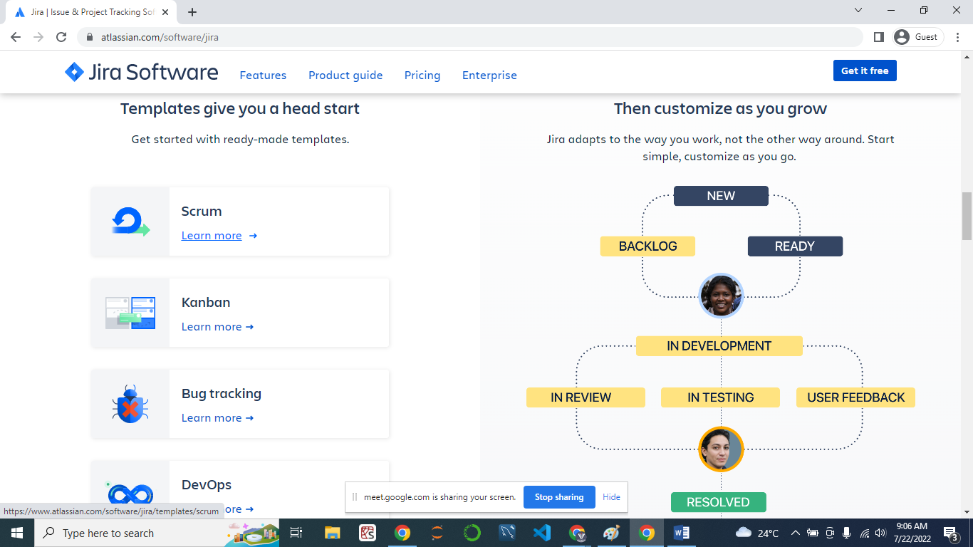
6. Click on Scrum.
7. 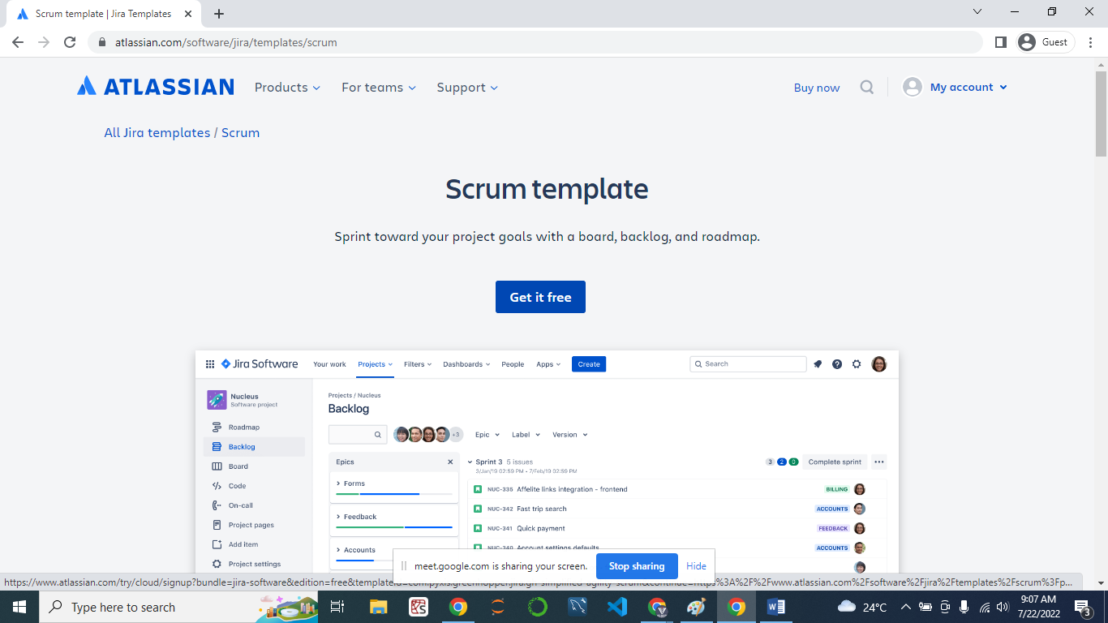
8. Click on get it free.
9. Click on Sign in with Google account
10. 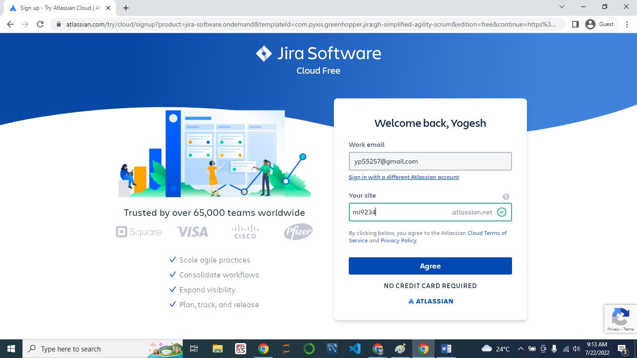
11. Click on Select a Team-managed Project option.
12. 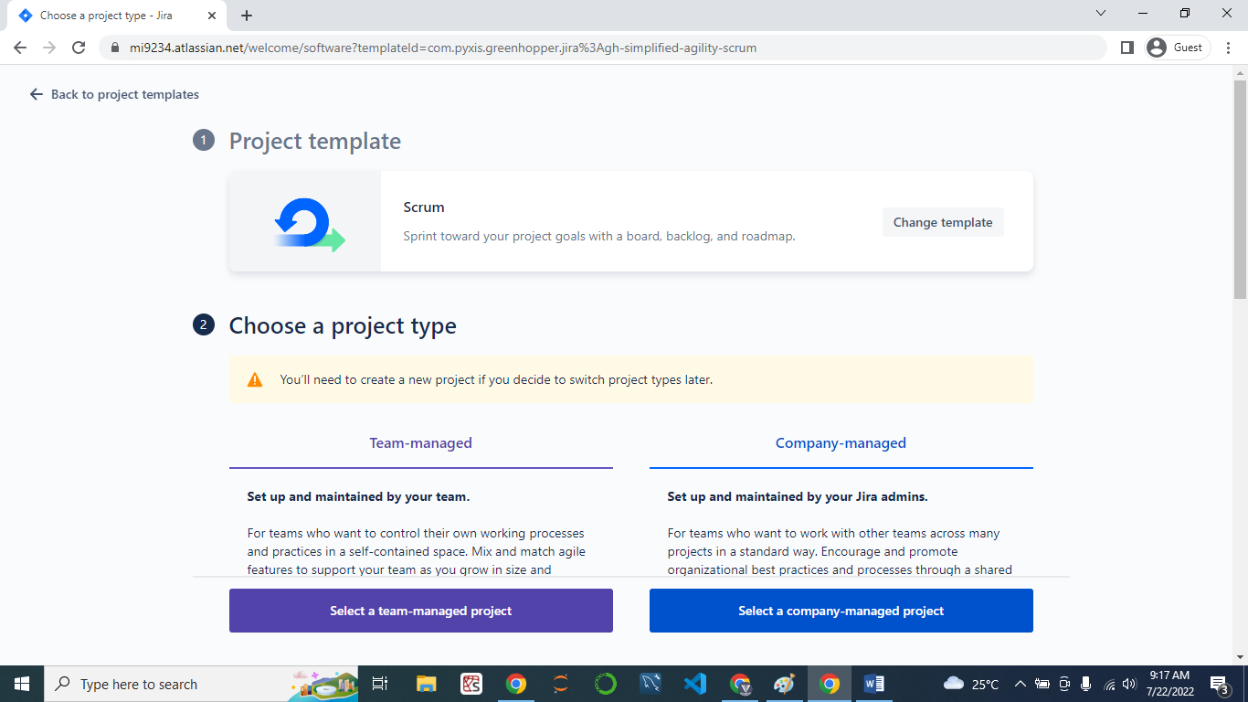
13. Provide the Name of Project Click on “Create Project”
14. 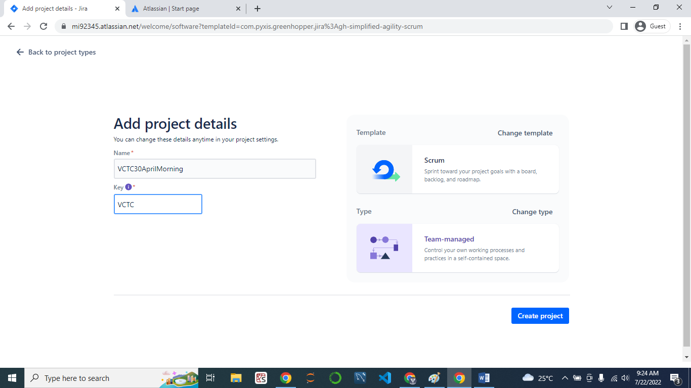
15. 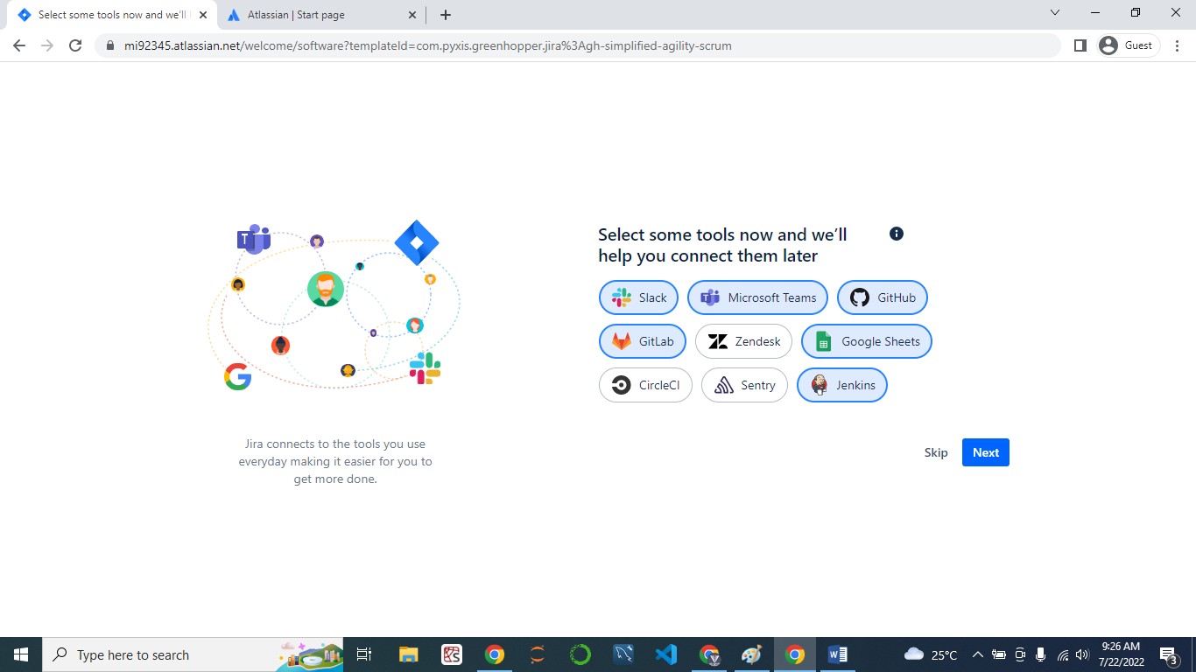
16. Click on Next
17. Invite Your Mates.

---------------------------------------------------------------------------------------------------------------------

# JIRA

* As Tester, I am writing **Test cases in** **excel sheet & these excel sheet link / attached with US**
* As Tester, in JIRA/US assigned to Me
* As Tester, for communication defects inform, Test cases Review, UAT team inform, etc
* As Tester, we will **create a defects** in JIRA/ HAPLM

# JIRA-

* **JIRA toll, it is a free version** project management toll/ defect tracking tool

**Q. What are field are present while lock/ create the defects**

* **Following field JIRA**

1. **Summery\***- Short description about the defects
2. **Description**\*- Steps to re-produced defect
3. **Assignee to**\* – Developer name
4. Re-producible – Y/ N
5. **Created by**\*- Tester Name
6. **Created date**\*-
7. Attachment/ Screenshot-
8. **Status**\*- New/ Open/ Fix/ Closed/ Rejected/ Re-open/Differed
9. **Severity*-**
10. Priority-
11. US link-

**Q. JIRA tool, frond end / UI which things are present?**

**Warnings**

1. **Do not change the reporter**
2. **Do not change or Update the Description or Acceptance criteria of User Story.**
3. **WRT US : QA has to change only Status and Assignee(Do not change the Sprint value / Fixed Version of the US)**
4. **When Log the Bug (Update the Sprint value when discuss with the Manager) Only fill the Fix Version.**

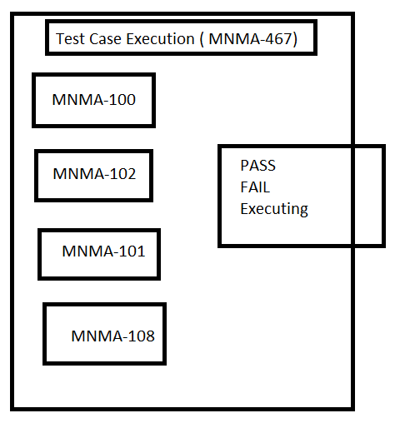

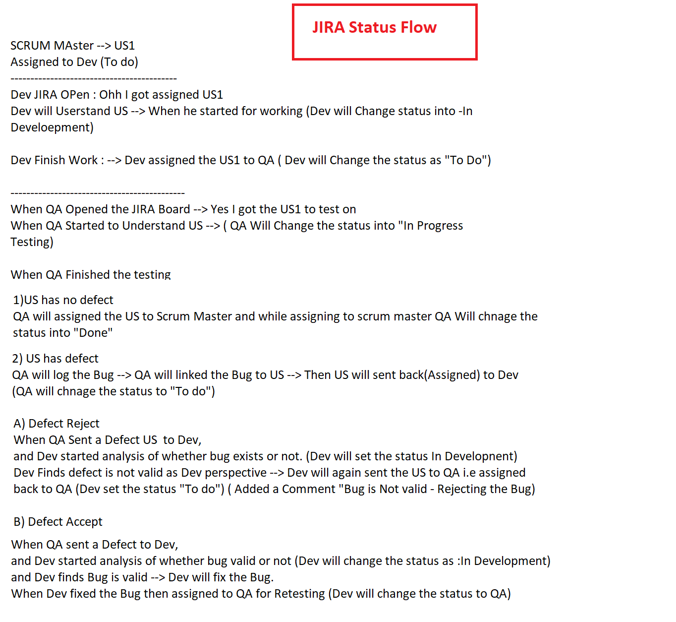

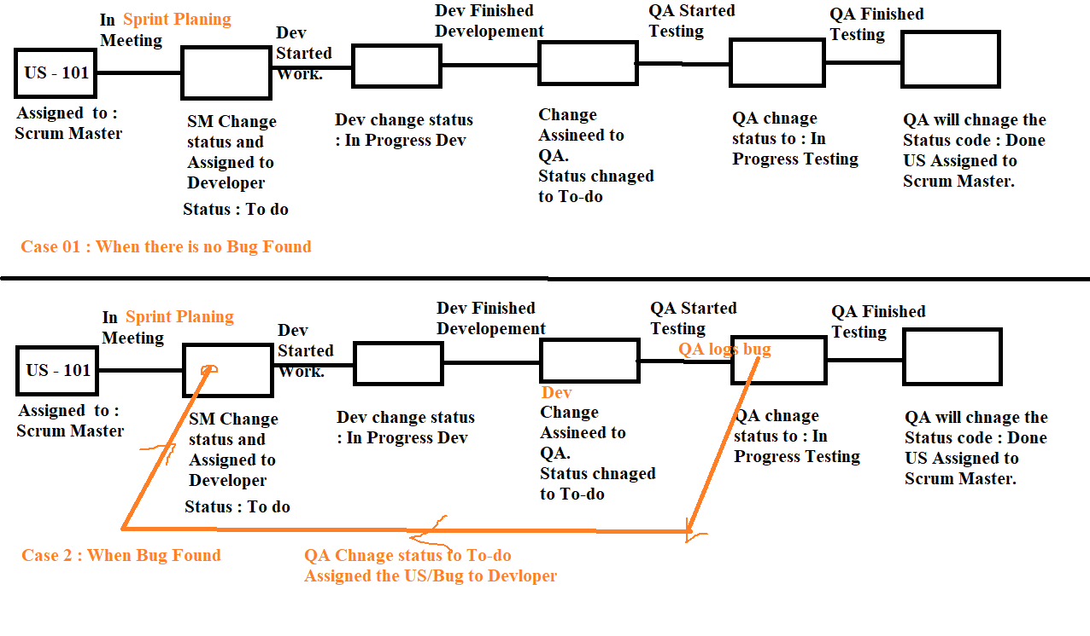

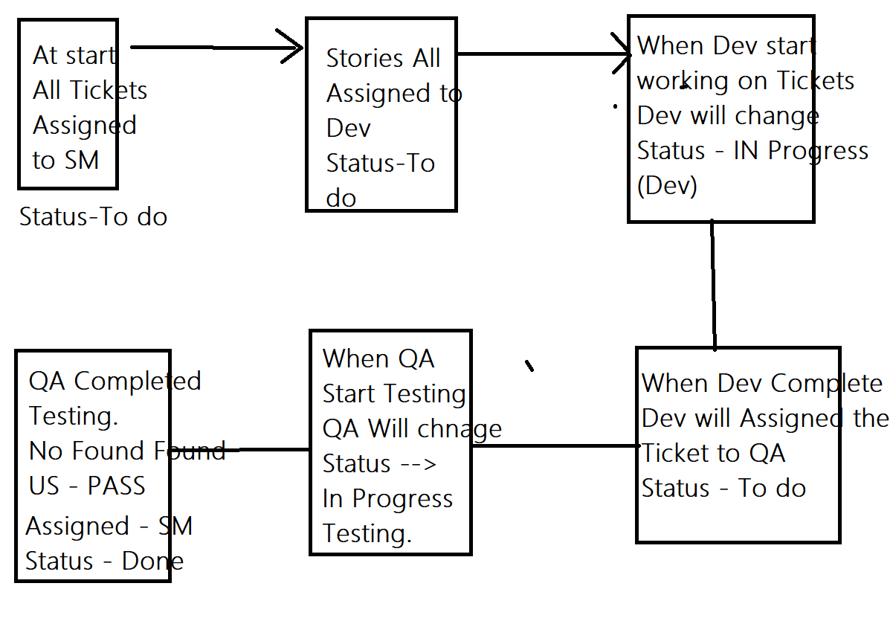

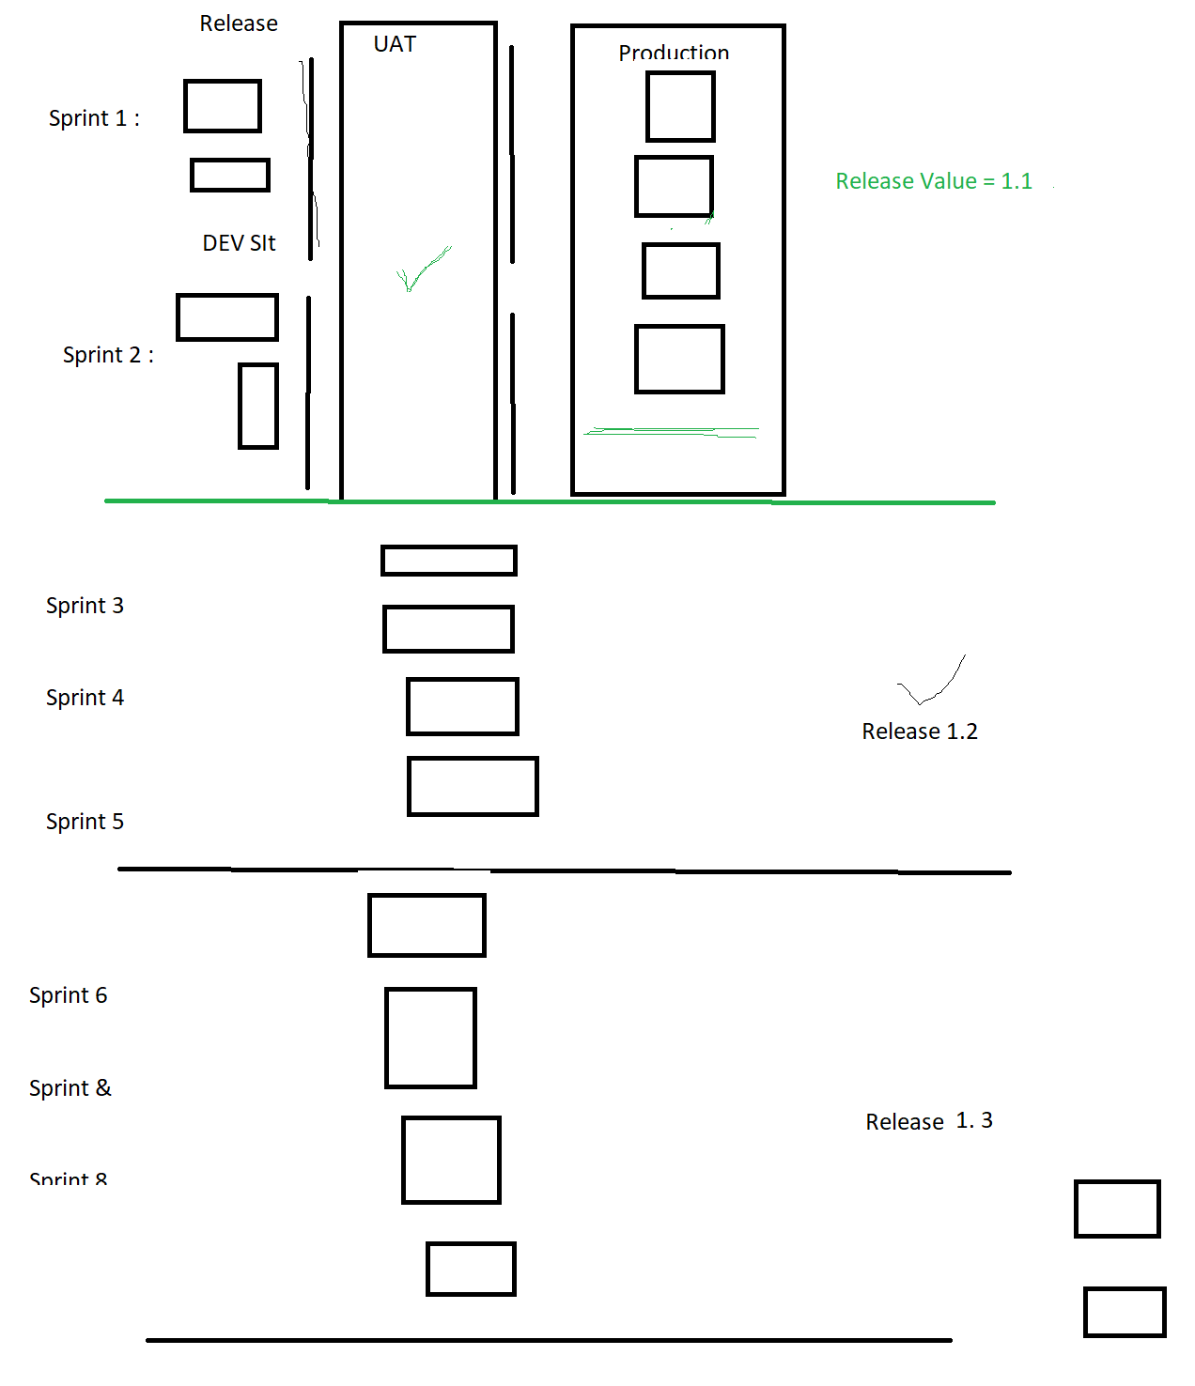

**Defect / Bug Logging**

1. **Click on Create button**
2. **Select Issue Type : Bug**
3. **Enter the Summary, Description, Fix Version.**
4. **Complete the other mandatory details**
5. **Click on Create button.**

**Work**

**Fastag Module 🡪 Ban of Baroda not working.**

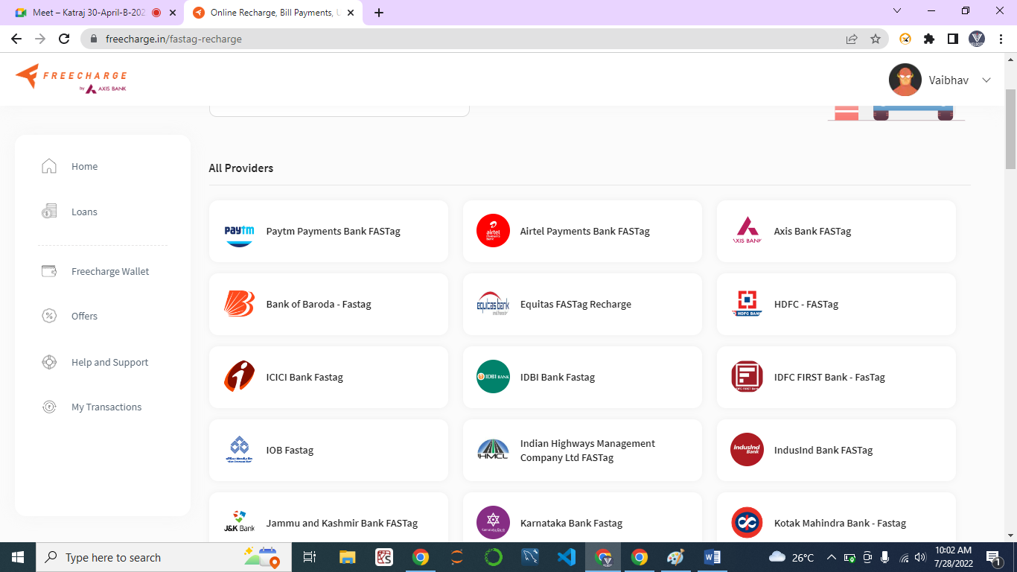

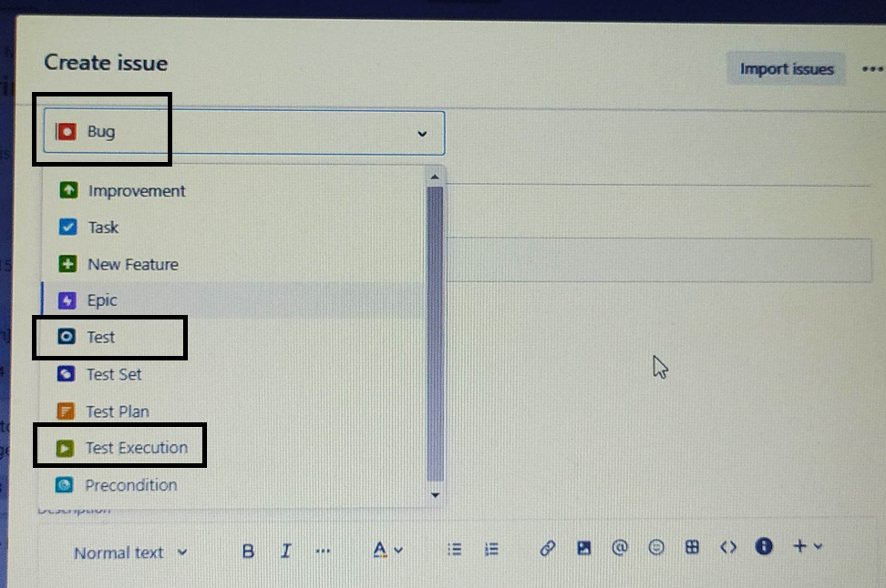

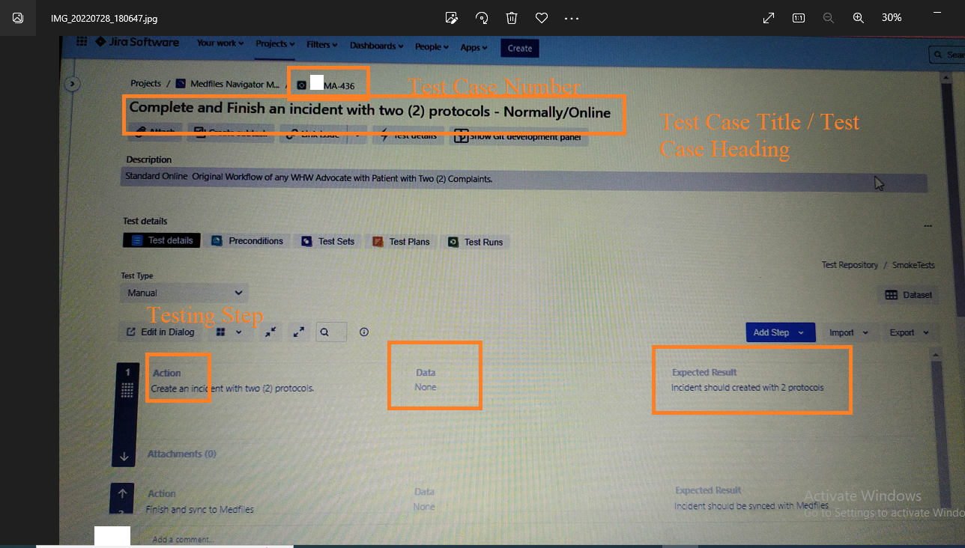

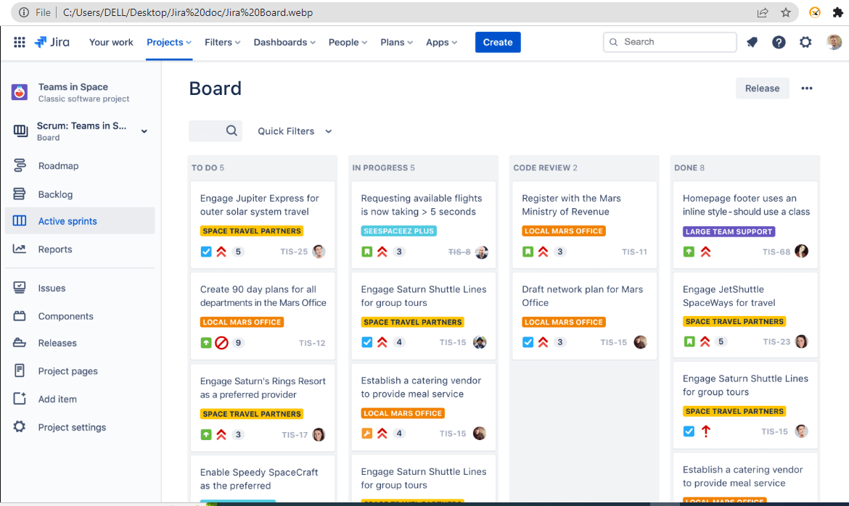

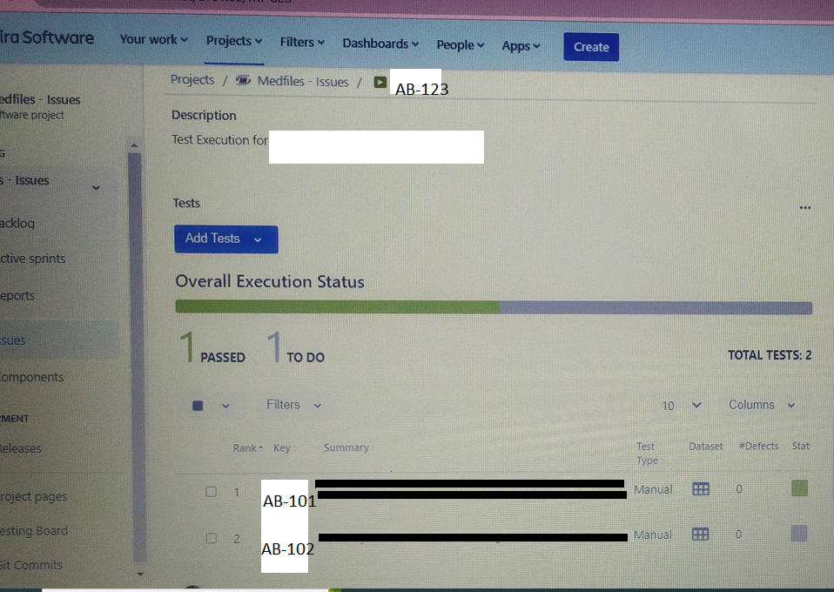

### **[Xray - Native Test Management for Jira](https://www.getxray.app/)**

[https://www.getxray.app](https://www.getxray.app/)